PROJECT REPORT

ON

**Online Aadhar card application**

**B.Tech (CE) Sem-IV**

**In the Subject of**

**SP Project Work**

**Nirav Jivani (CE-051) (19CEUOS083)**

**Jenil Patel (CE-050) (19CEUOS152)**

Under the Guidance of

**Prof. Brijesh S. Bhatt**



**Department Of Computer Engineering**

**Faculty Of Technology,**

**Dharmsinh Desai University, Nadiad.**

**DHARMSINH DESAI UNIVERSITY**

College Road, NADIAD-387001 (Gujarat)



**CERTIFICATE**

This is to certify that the term work carried out in the subject of **Python project**

and recorded in this report is Bonafede work of

**Mr. Nirav Jivani (Roll No.: 051, Id: 19CEUOS083)** ,

**Mr. Jenil Patel (Roll No.: 050, Id: 19CEUOS152)**

of **B.Tech Semester 4th** in the branch of Computer Engineering during the academic year 2020-21.

Prof. Brijesh S. Bhatt

Prof. Pinkal Chauhan

Prof. Jigar pandya Dr. C.K. Bhensdadia

(Project Guide and Associate Professors) Head of CE Dept.,

Faculty of Technology, Faculty of Technology,

Dharmsinh Desai University, Dharmsinh Desai university

Nadiad. Nadiad.

**Contents**

1. Abstract………………………….……………………………..4

2. Introduction…………………….…………………………...5

3. Software Requirement Specifications….……………....7

4. Design………………………………………………...10

5. Implementation Detail……………………………..20

6. Testing………………………………………………...21

7. workflow/Screen-shots…………………………….......22

8. Conclusion………………………………………………….35

9. Limitation and Future Extension…………………………….36

10. Bibliography……………………………………………….37

**1. Abstract**

Now a day covid-19 is in action so people have to avoid going outside of home.so in this time everything is going digital and online work and avoid crowed at gov corporation for get necessary document.

To overcome these situation, there arise a need for online Aadhar card application. Online Aadhar card application web is built for the same reason. It’s helps Indian residents to apply new Aadhar , download Aadhar card , update in their Aadhar card at their own home without visit gov corporation.

**2. Introduction**

**1.1 Introduction of Online Aadhar card Application WEB**

Online Aadhar card application web is built for the Indian resident. It’s helps Indian residents to apply new Aadhar , download Aadhar card , update in their Aadhar card at their own home without visit gov corporation and very quick at any time any where.

**Features of Online Aadhar card Application:-**

* Users can apply new Aadhar card.
* Users can see/download Aadhar card details.
* In case of any update in detail of Aadhar card user can also update details.
* User can generate Aadhar card number using VID or generate master otp.

**1.2 Technology/Platform/Tools Used**

**Django :**

Django is the official web development framework of python. Which provide best platform for web development using python.

**Python :**

Python is a general-purpose programming language that is class-based, object-oriented, and designed to have as few implementation dependencies as possible.

**Html :**

Html used to describe data.it is well readable both by human and machine. It is scalable and simple to develop. In Web it is used for designing web s as html is lightweight language.

**Twillio message sending System:**

Twillio library use for send one time password to user’s mobile number for user verification.

**3. Software Requirement Specifications**

**Online Aadhar card Application :-**

**R1. New Aadhar Application**

**R.1.1 Signup**

Description :

For new applicant, he/she have to sign up at 1st time.

Input: necessary details

Output: display message

Process: fill from for signup and get username and password.

**R.1.2 Login**

Description :

User have to sign for use functionality of web application.

Input: user name and password

Output: home page of web

**R.1.3 Apply New Aadhar**

Description :

A portal to apply for Aadhar Card, a form to be filled to

Issue Aadhar Card; Some necessary Documents are needed to be attached with the Form. then submit form and get message that user’s application for new Aadhar card is accepted.

• Input: fill the form and upload documents

• Output: display message

• Process: fill form correctly and submit it for verification.

**R2. Update in Aadhar details**

**R.2.1. NAME UPDATE:**

Description:

select update name option and enter modified name and submit it. After submitting user redirect to update page.

• input: modified name

• output: display message and redirect to update portal

• Process: click on change name fill form and submit it. It’s modify user’s name.

**R.2.2. ADDRESS UPDATE:**

Description :

select update name option and enter modified address and

submit it. After submitting user redirect to update page.

• input: Modified address

• output: display message and redirect to update portal

• Process: click on change address fill form and submit it. It’s modify user’s address.

**R.2.3. PHOTO UPDATE:**

Description:

select update photo option and upload new photo and submit it. After submitting user redirect to update page.

• input: upload new photo

• output: display message and redirect to update portal

• Process: click on change photo and upload photo and submit it. It’s update user’s photo.

**R.2.4. EMAIL OR MOBILE NUMBER UPDATE:**

Description :

select update mobile number/email option and enter new mobile number/email and verify using otp and submit it. After submitting user redirect to update page.

• input: new mobile number/email and otp

• output: : display message and redirect to update portal

• Process :click on change email/number fill form and enter otp and submit it. It’s update user’s mobile number/email.

**R.2.5. DATE OF BIRTH UPDATE:**

Description :

select update DOB option and enter new DOB and submit it. After submitting user redirect to update page.

• input: new date of birth

• output: display message and redirect to update portal

• Process: enter new birth date and submit it. It’s update user’s birth date.

**R.3 Generation and verification**

**R.3.1 Generate Aadhar Number**

• Input: click on generate Aadhar number. And enter user’s VID number

• output: display user’s VID number

**R.3.2 Master otp**

Description :

Click this to get an otp that can be used to get Aadhar details,

get/retrieve Aadhar no., temporary access for verifications, used to get

E-Aadhar and simple mobile number verification.

• input: enter mobile number

• output: display otp with message (valid still you not leave)

**R.3.3 Download Aadhar card**

description:

user enter Aadhar number and mobile number and otp.

Then E-Aadhar will download.

• Input: Aadhar number , mobile number and otp

• Output: E-Aadhar card

**4. Designs**

* **Usecase Diagram :-**

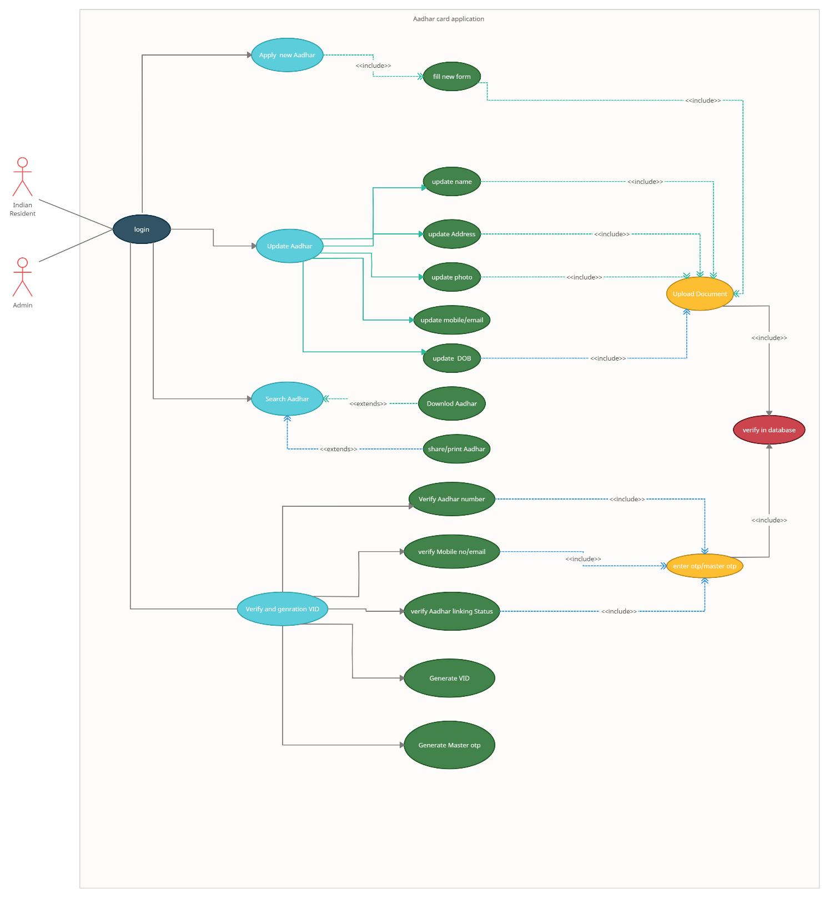

* **Class Diagram :-**

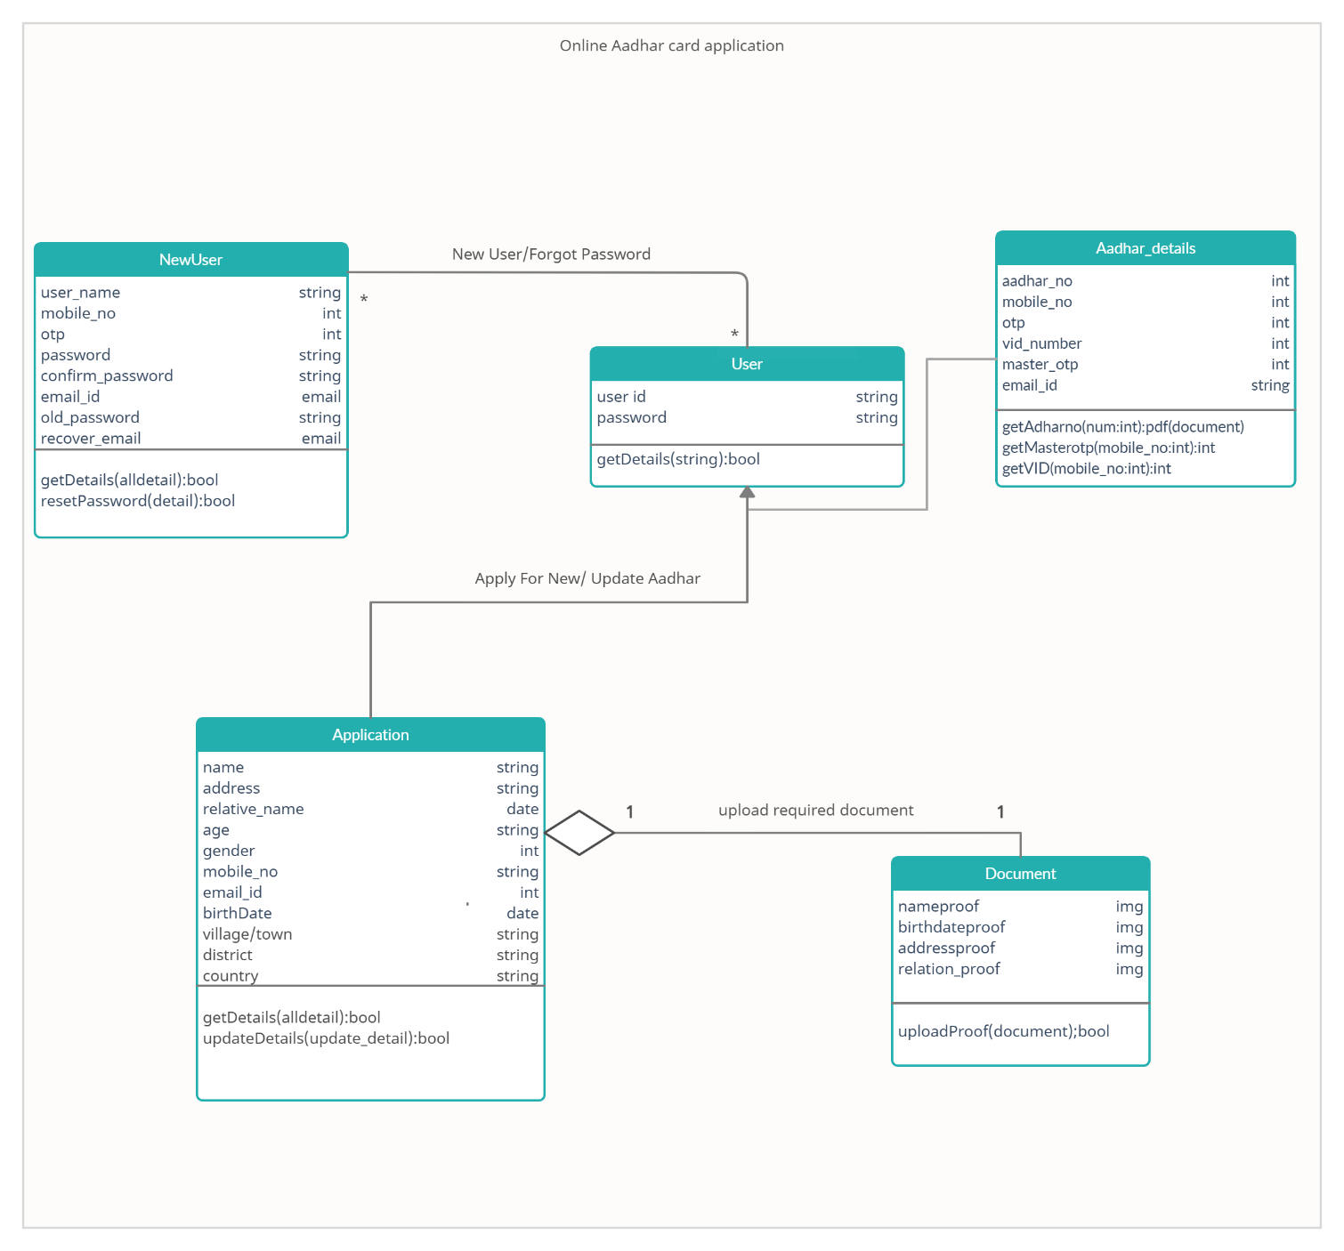

* **Sequence Diagram :-**

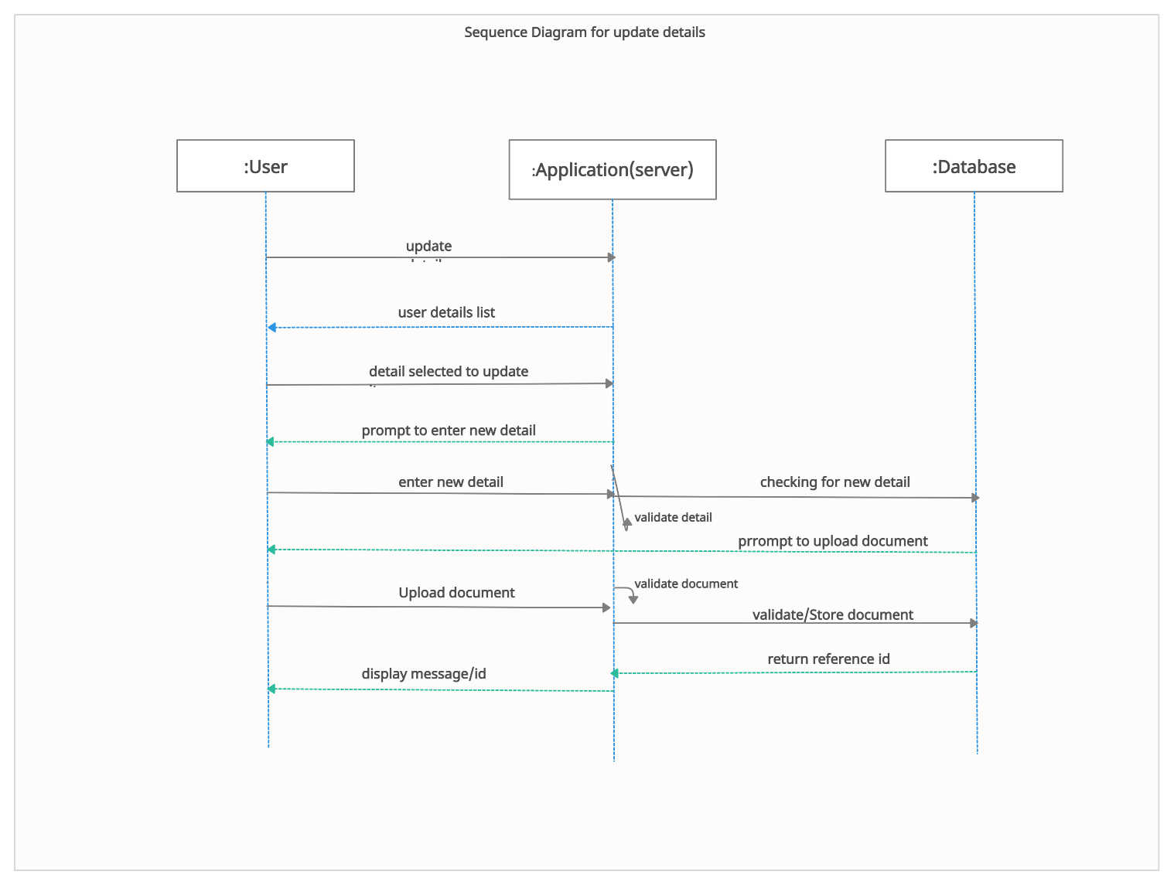

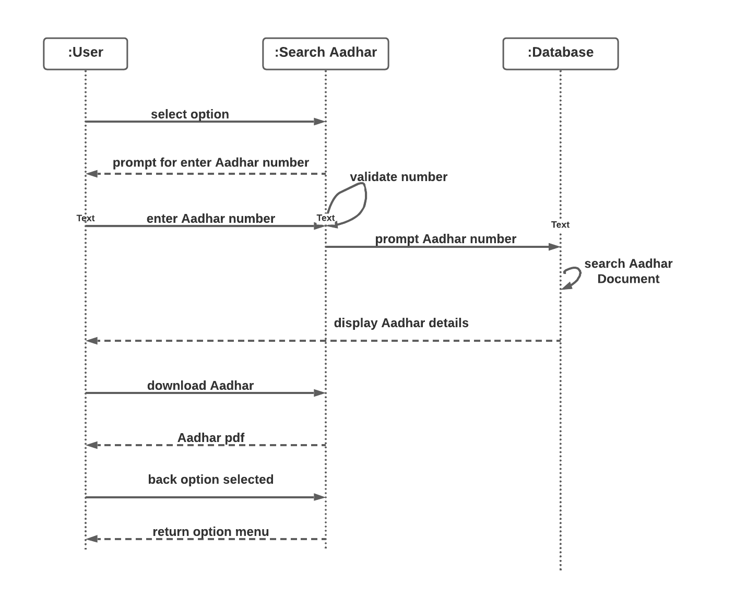

* **Activity Diagram :-**

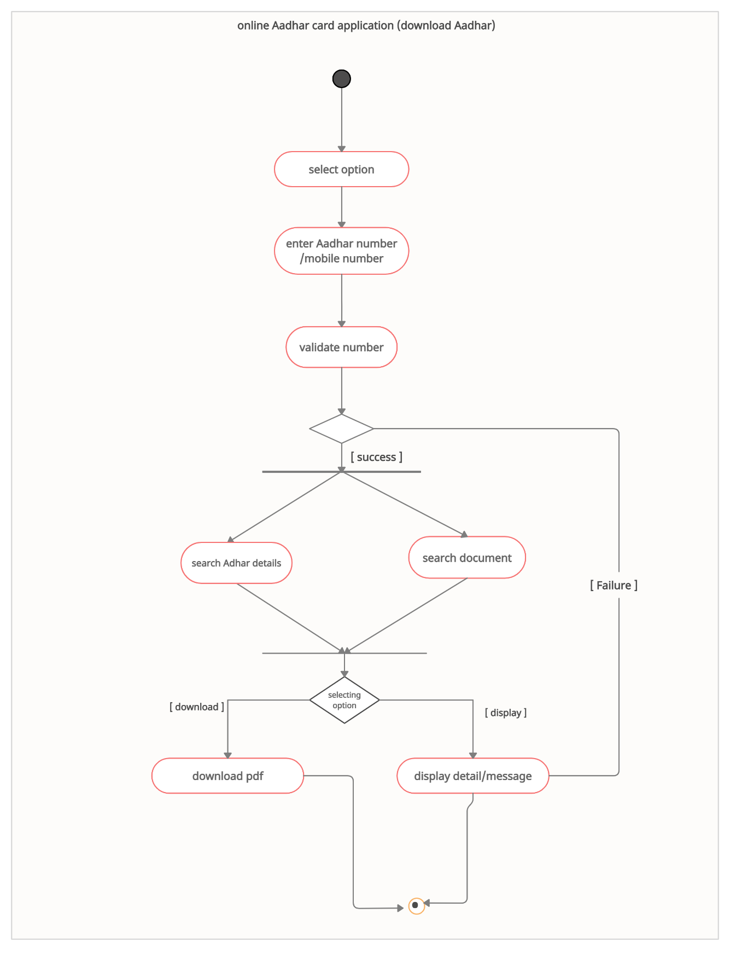

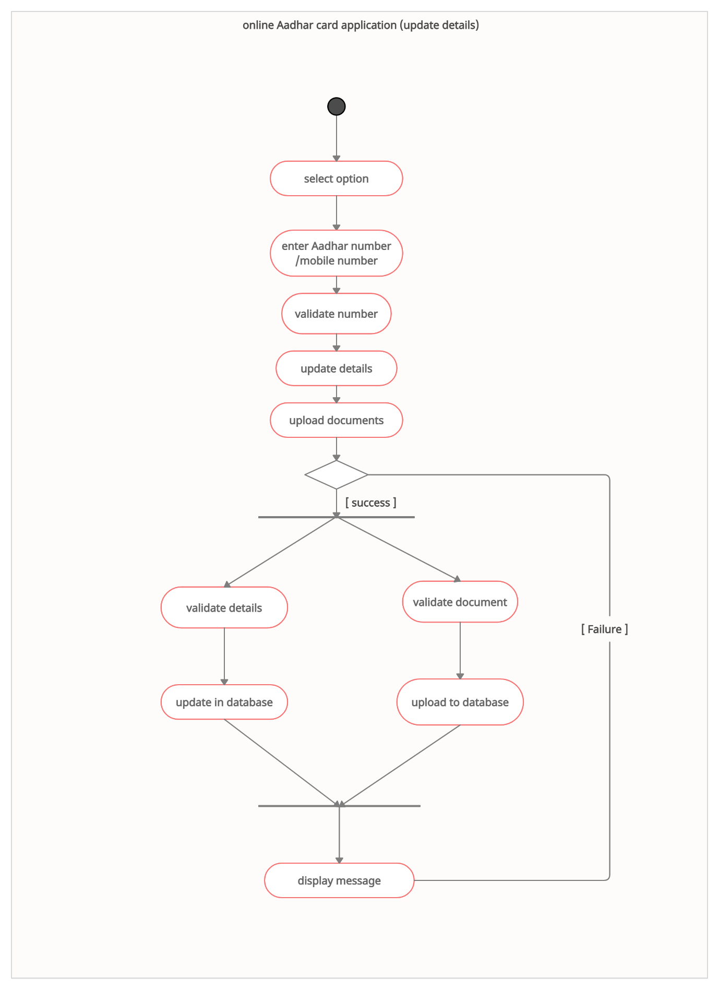

* **Data Flow Diagrams: -**

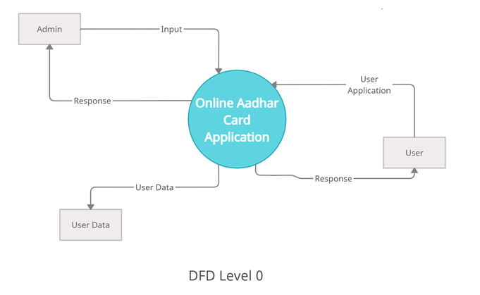

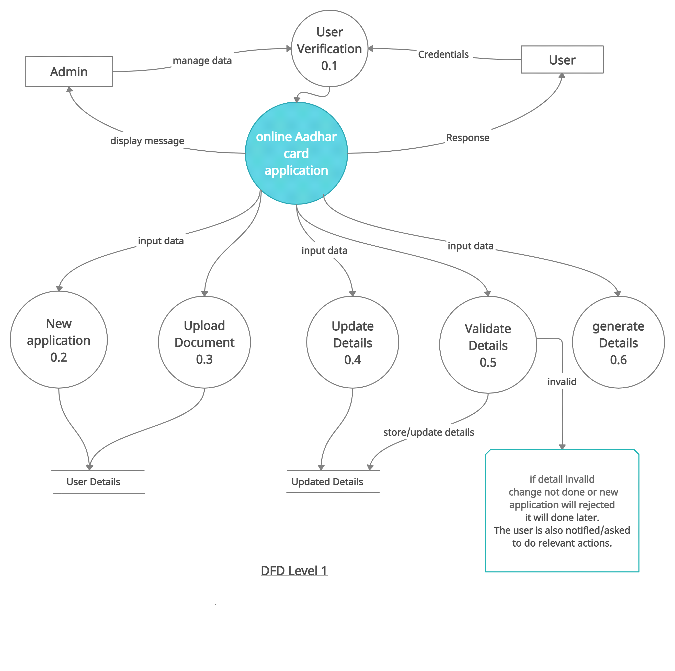

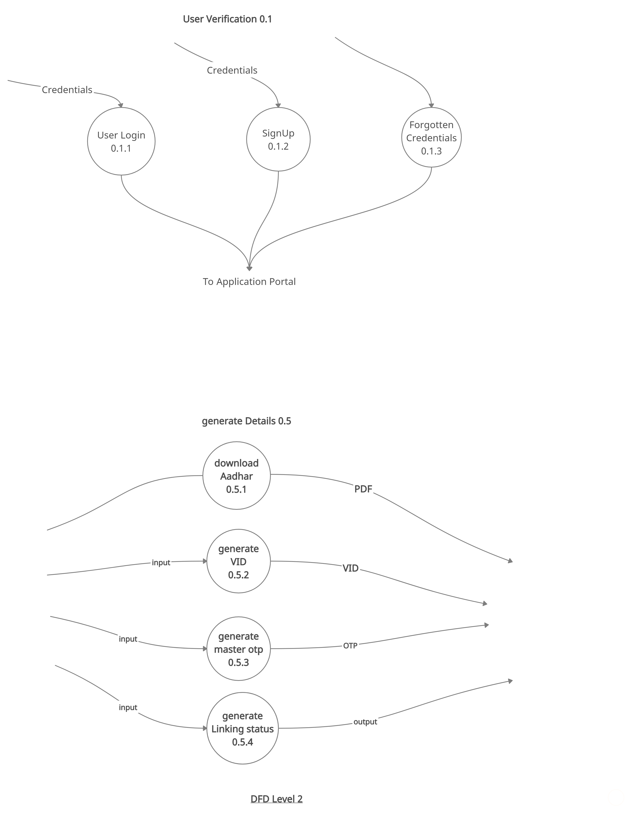 **Structure Diagram :-**

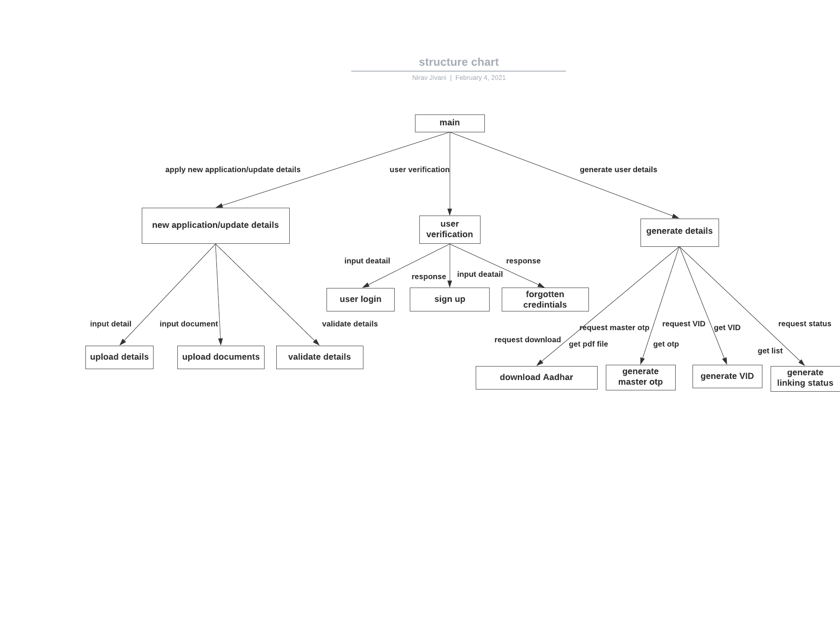

* **Data Dictionary :-**

Auth_User

|  |  |  |
| --- | --- | --- |
| Name of Field | Datatype | Length |
| id | int | 11 |
| Password | Varchar2 | 128 |
| Last_login | datetime | 6 |
| Is_superuser | tinyint | 1 |
| username | Varchar2 | 150 |
| Last_name | Varchar2 | 150 |
| email | Varchar2 | 254 |
| Is_staff | tinyint | 1 |
| Is_active | tinyint | 1 |
| Date_joined | datetime | 6 |

User Details

|  |  |  |
| --- | --- | --- |
| Name Of Field | DataType | Length |
| **id** | int | 11 |
| **name** | Varchar2 | 20 |
| **gender** | Varchar2 | 10 |
| **address** | Varchar2 | 100 |
| **Relationtype** | Varchar2 | 20 |
| **relativename** | Varchar2 | 20 |
| **birthaddress** | Varchar2 | 20 |
| **birthdate** | date |  |
| **number** | bigint | 20 |
| **email** | Varchar2 | 254 |
| **rdate** | date |  |
| **fdate** | date |  |
| **Place** | Varchar2 | 20 |
| **Addf** | Varchar2 | 100 |
| **Addfname** | Varchar2 | 20 |
| **Agef** | Varchar2 | 100 |
| **agefname** | Varchar2 | 20 |
| **phf** | Varchar2 | 100 |
| **vid** | bigint | 20 |

**5. Implementation Details**

**4.1 Description of Modules :-**

**1. Register User Module**

Basic information of user is taken by system and stored in database.

**2. Login User Module**

Users are able to login themselves. System logs user in, then and only then user can use other functionalities of system.

**3. Apply new Aadhar Module**

User can fill all require form for new application and get vid number for reference.

**4. update details Module**

User can select option which field he/she want to update and then give new details and require document.

**5. download Aadhar Module**

User have to enter Aadhar number , register mobile number and one time password verification and get their Aadhar card ready.

**6. Generate Aadhar number**

User can enter vid number ,register mobile number and one time password verification and get their Aadhar number.

**7. generate master otp**

User use master otp as one time password at every require filed.

**6. Testing::manual**

|  |  |  |  |  |
| --- | --- | --- | --- | --- |
| **Sr.no** | **Test case** | **Expected result** | **Actual result** | **status** |
| 1. | Registration with already register number/user name | Display message user name/ email already register | Pop message: ‘username/number already register’ | Success |
| 2. | Registration with correct Credentials | System should waiting for OTP verification. | Asked for OTP which sent to user’s mobile number | Success |
| 3. | Login with incorrect Credentials | System should given message :-‘incorrect user name or password’ | Pop up message:  ‘user name and password must be correct’ | Success |
| 4. | Login with correct credentials | System should Redirect to home of the web | Redirect to home page of user | Success |
| 5. | Forgot Password | System should send otp to register mobile number and verify it | s OTP which sent to user’s mobile number | Success |
| 6. | Otp verification fail | System should display message invalid otp please enter valid otp | Display message:  ‘invalid otp please enter valid otp ’ | Success |
| 7. | Download Aadhar/  Update Aadhar number verification fail | System should display message invalid number or number doesn’t register | display message:  ‘ invalid number or number doesn’t register’ | Success |
| 8. | Number verification  success | System should display According Functionality page | Redirect to page According to functionality | Success |

**7. workflow/ Screenshots**

**Login panel:**

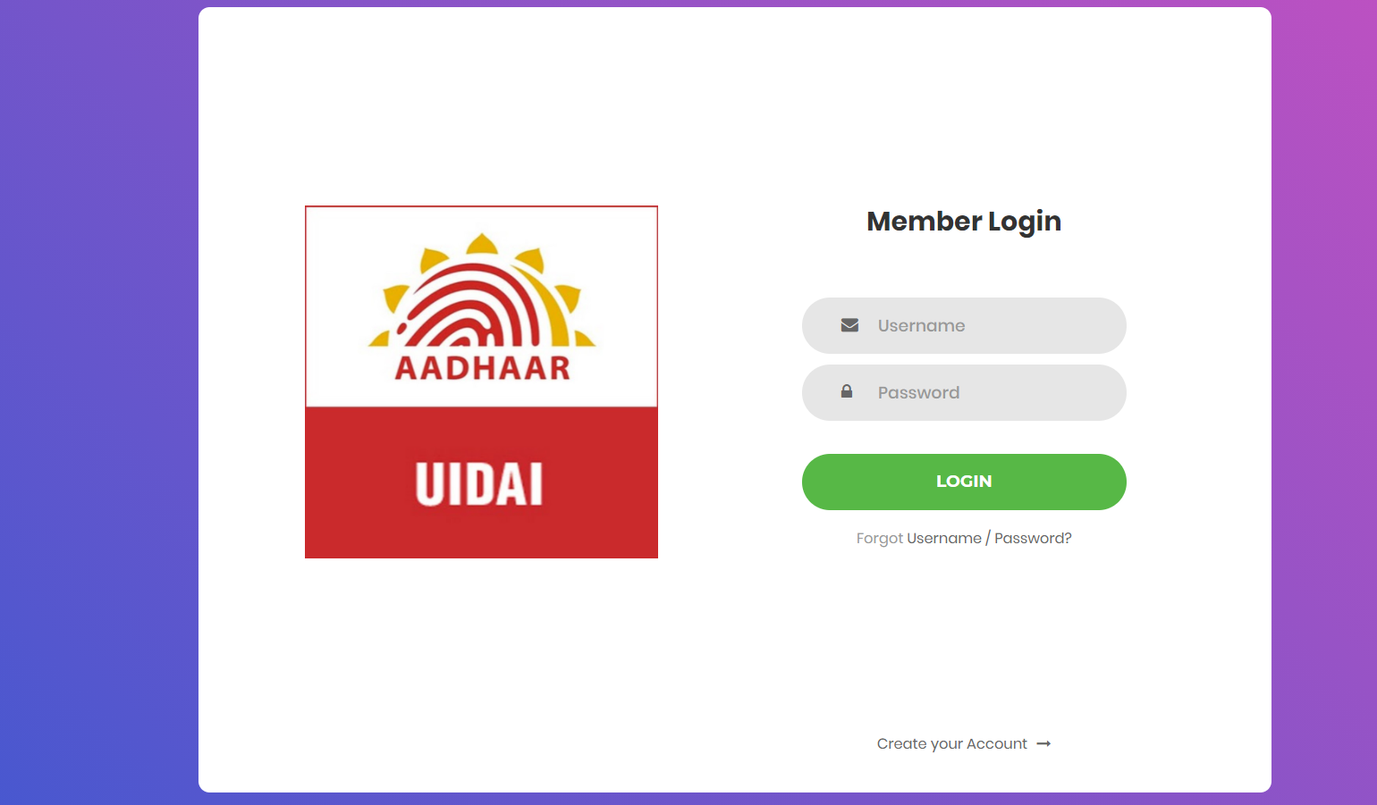

**I.Create/signup:**

**1. panel**

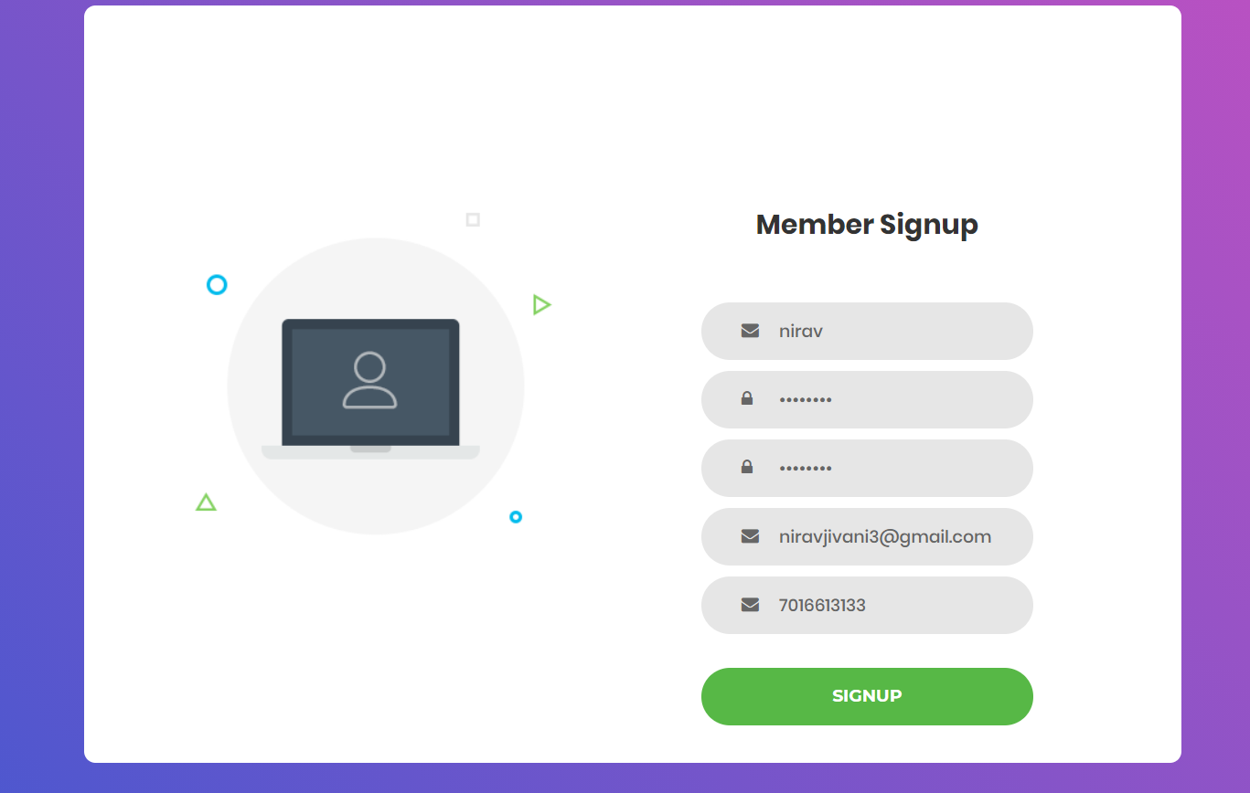

**2. Mobile number verification:**

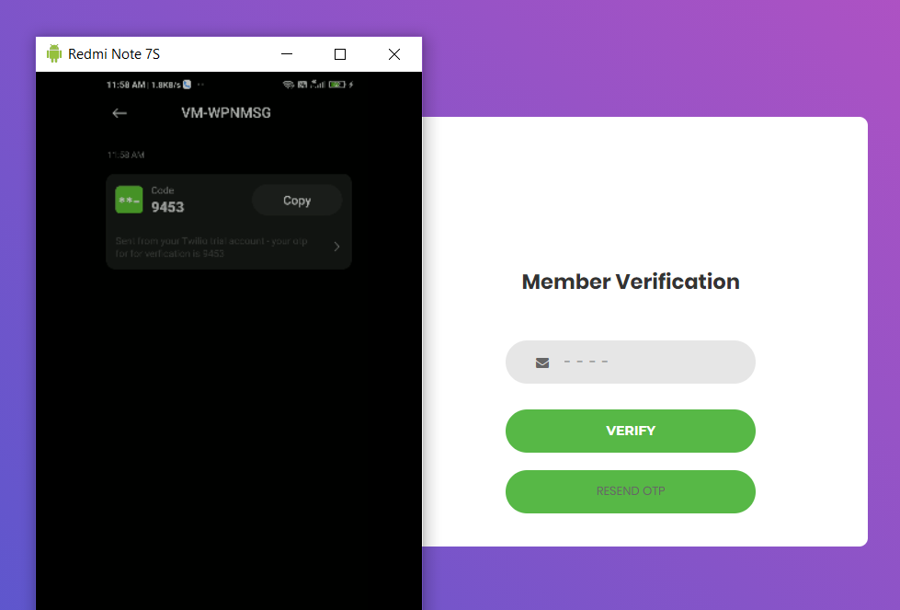

**II.Forgot panel:**

1. **Mobile verification**

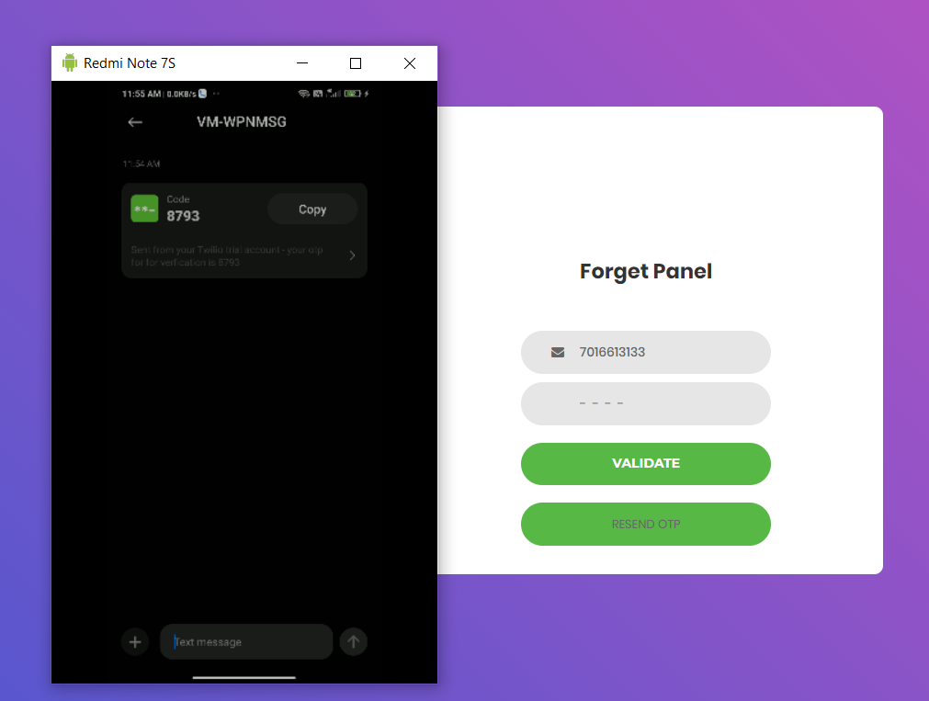

1. **reset panel**

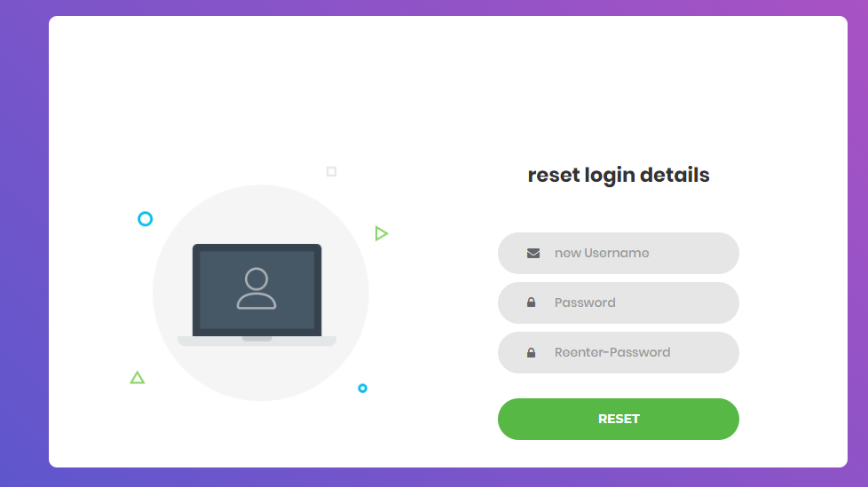

**Logged in:**

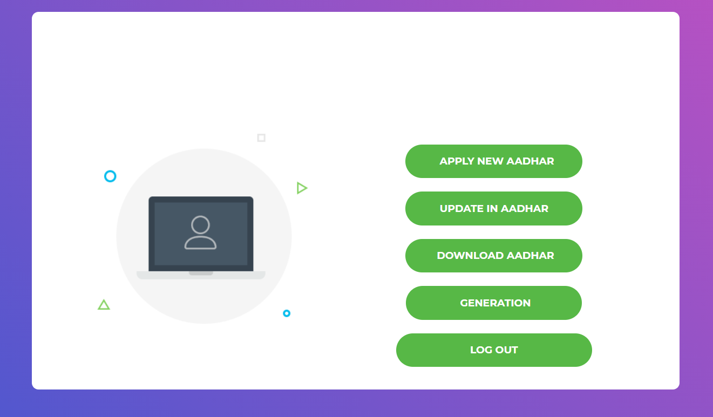

**III. New Aadhar card:**

1. **address**

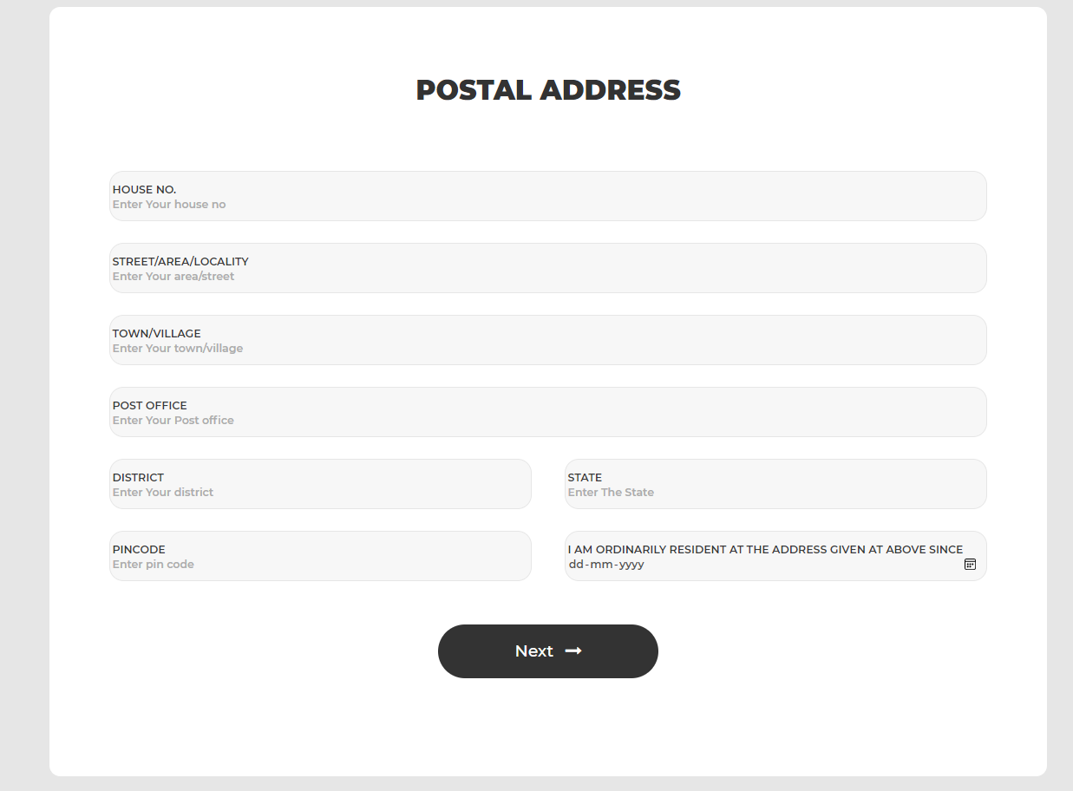

1. **birth**

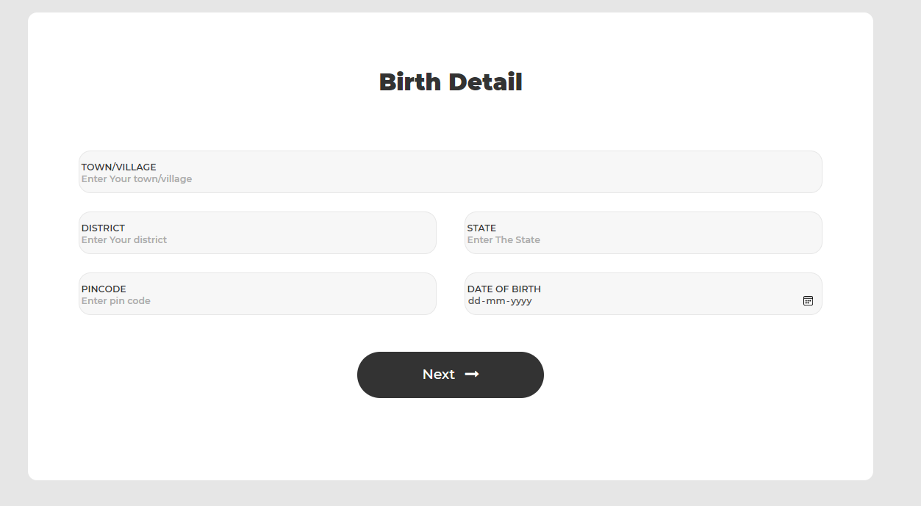

1. **relative details**

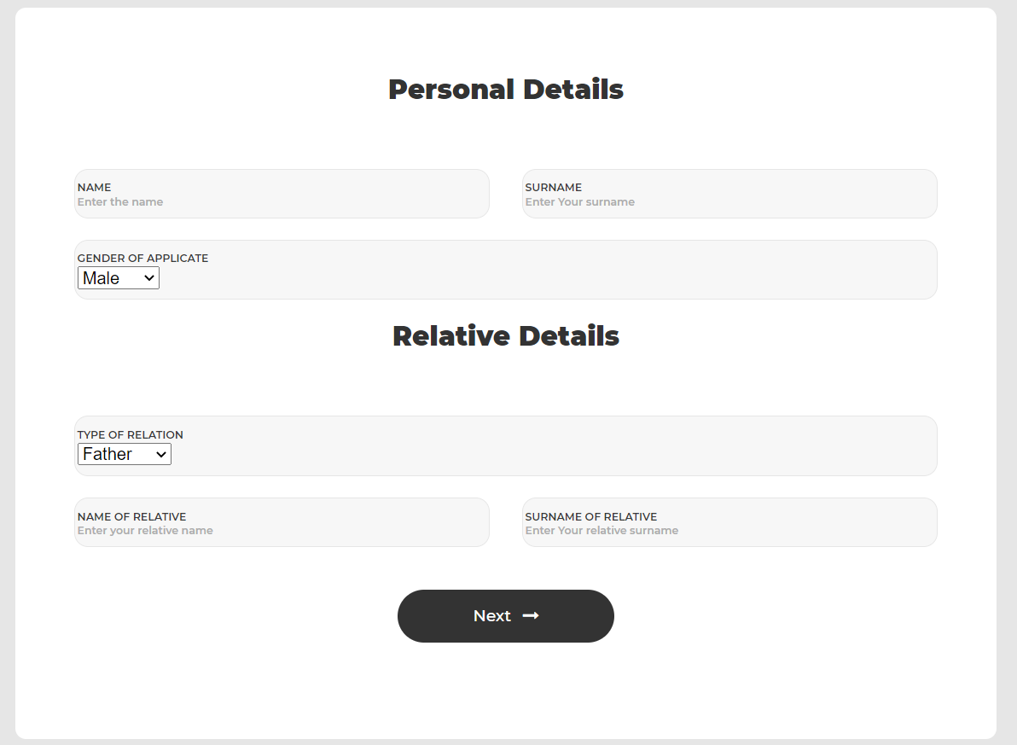

1. **additional details/declaration**

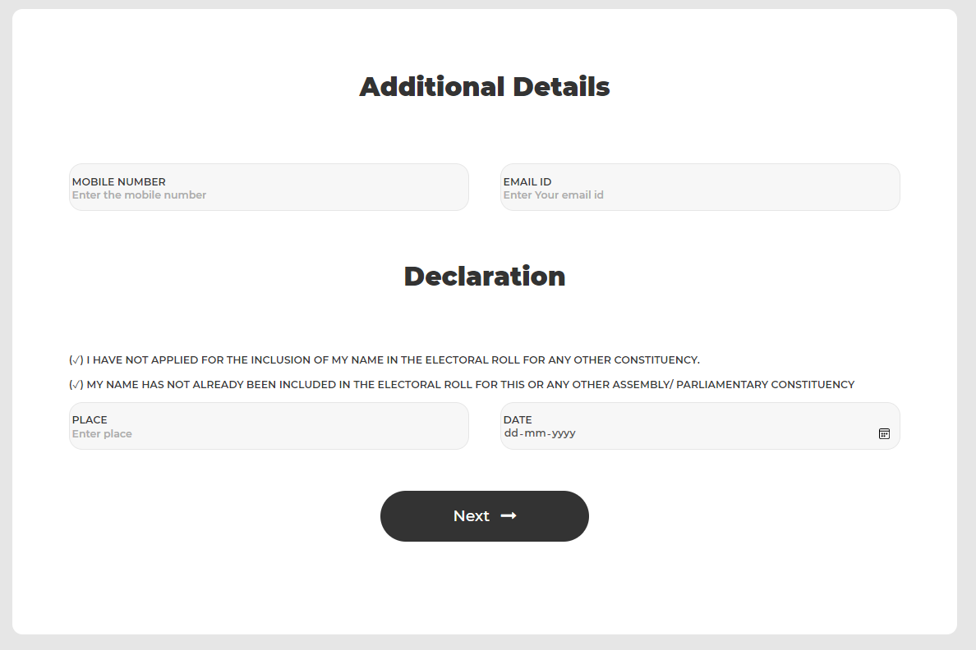

1. **document upload**

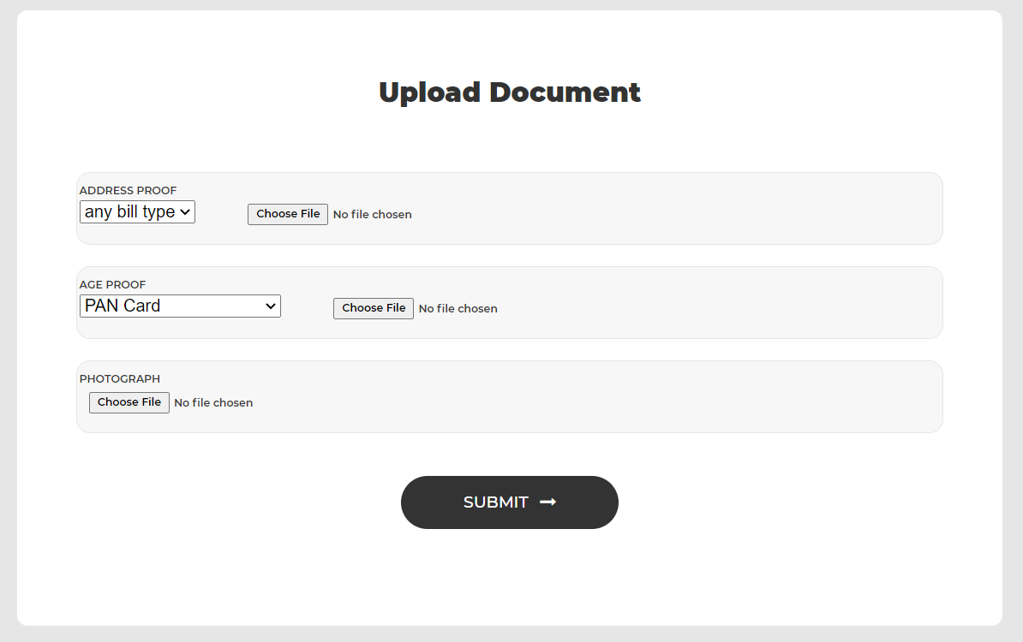

1. **final submission**

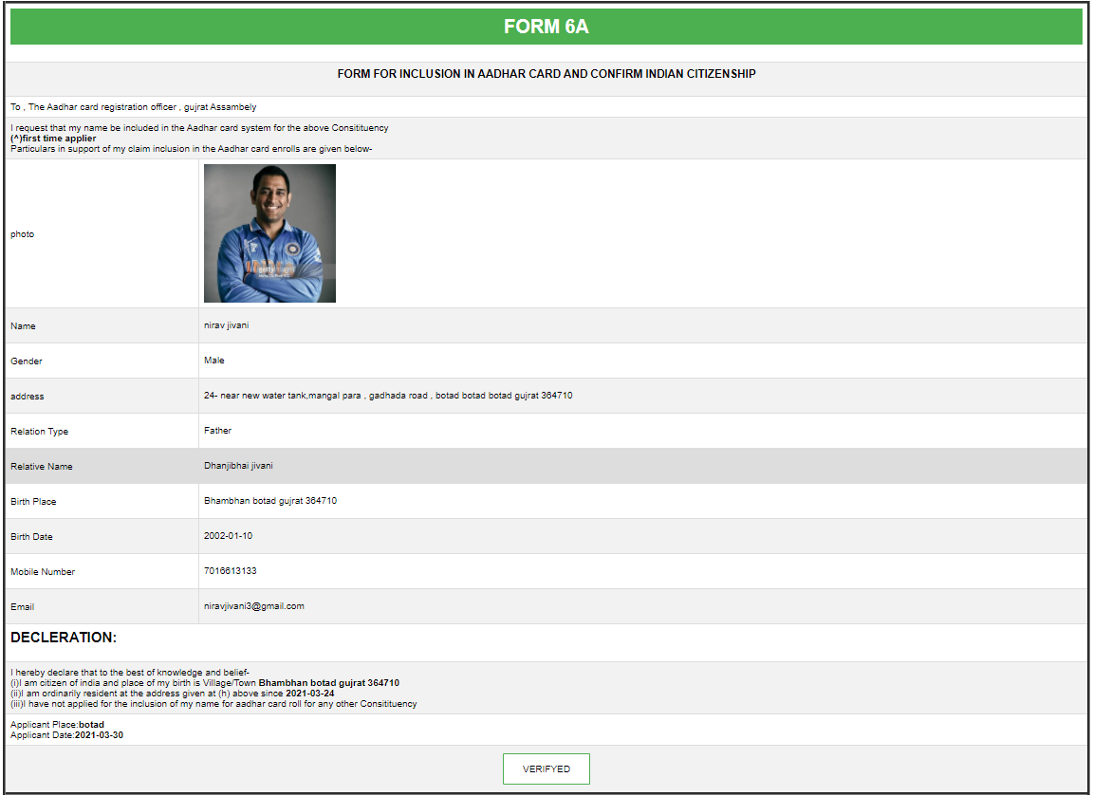

1. **vid number**

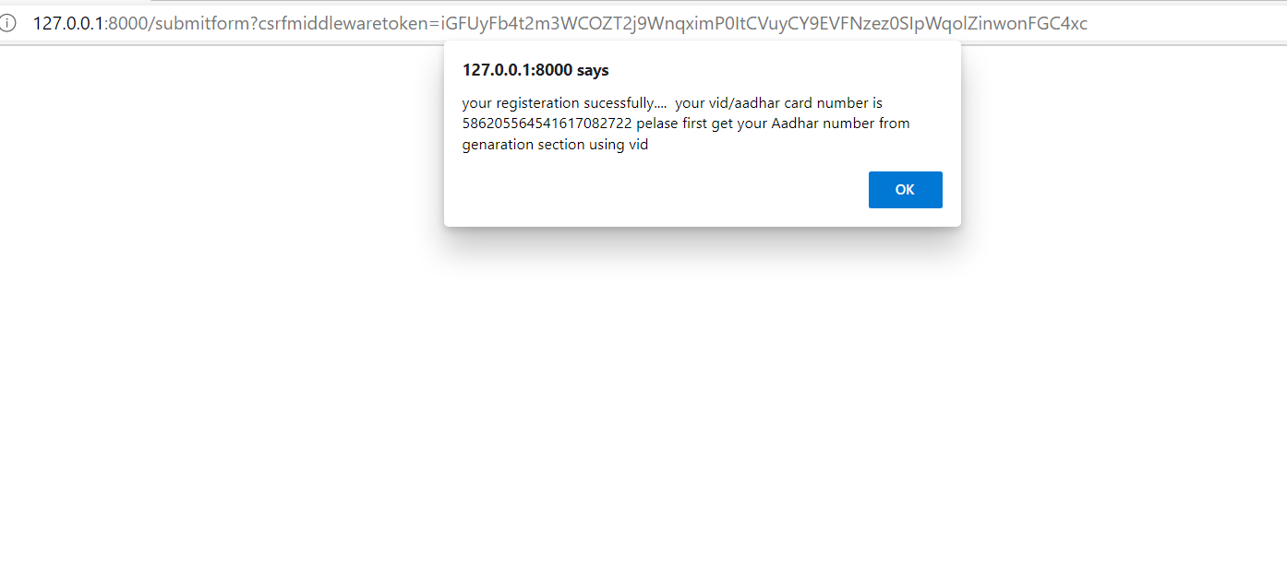

**IV. generation**

1. **Portal**

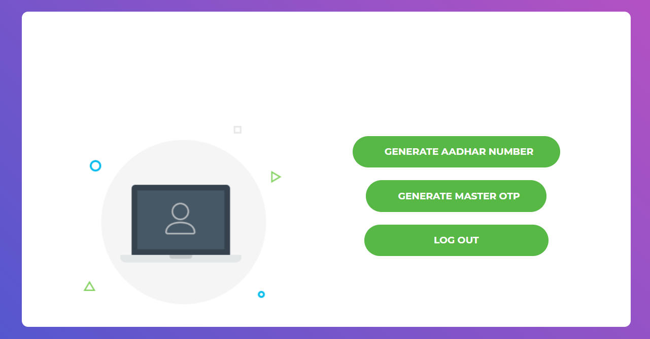

1. **Generate number**

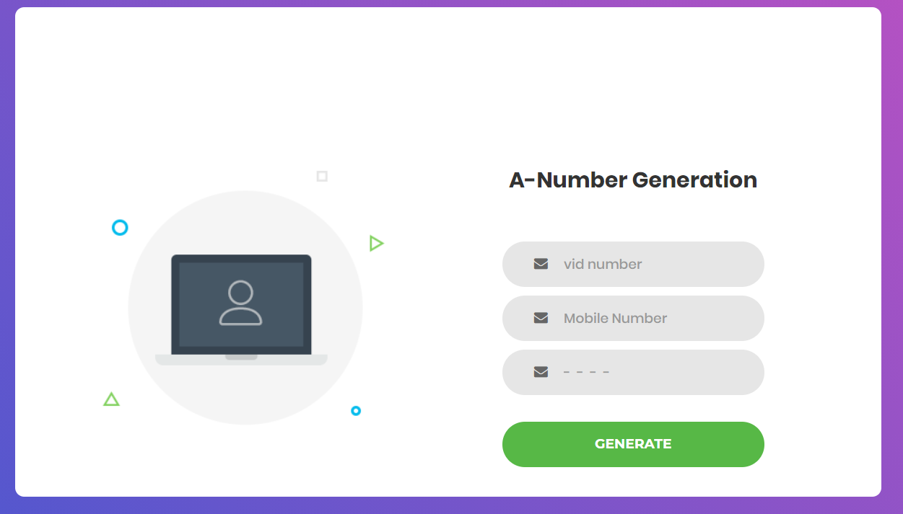

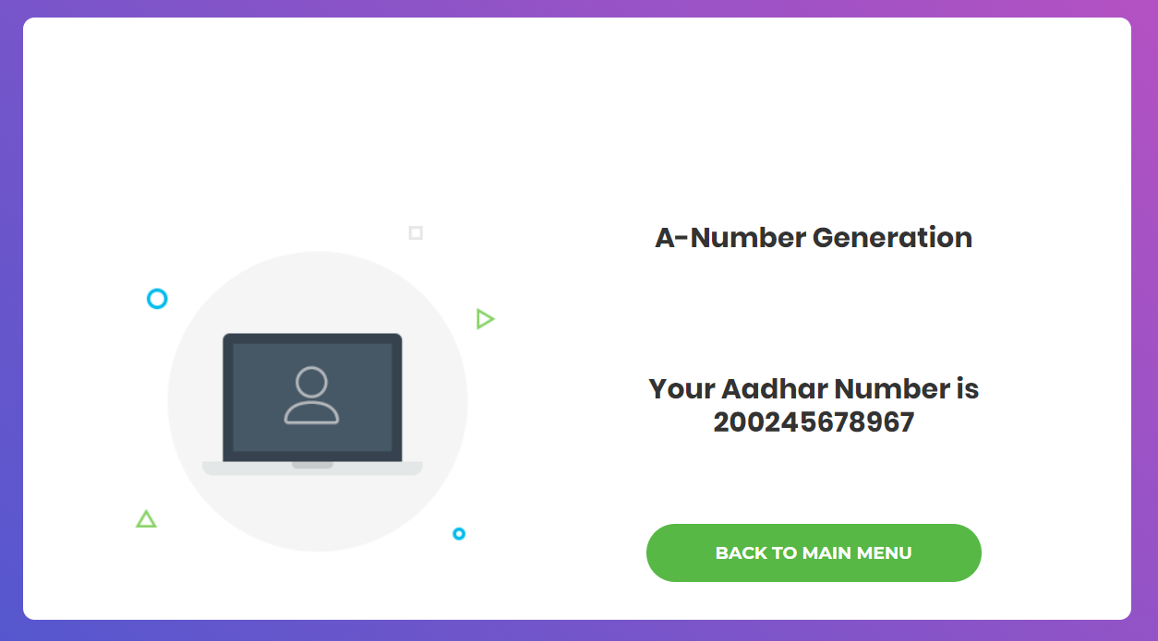

**3.master otp generation**

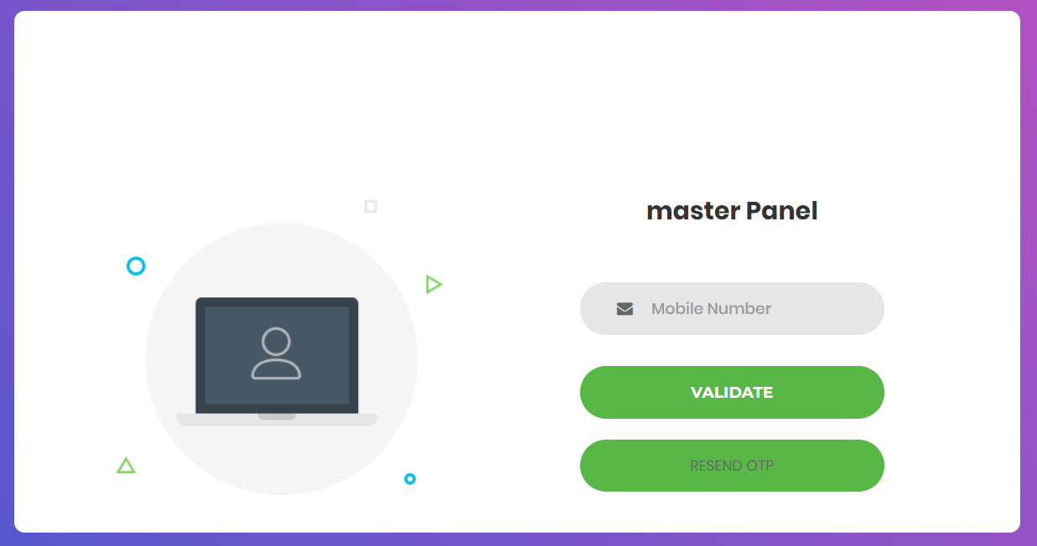

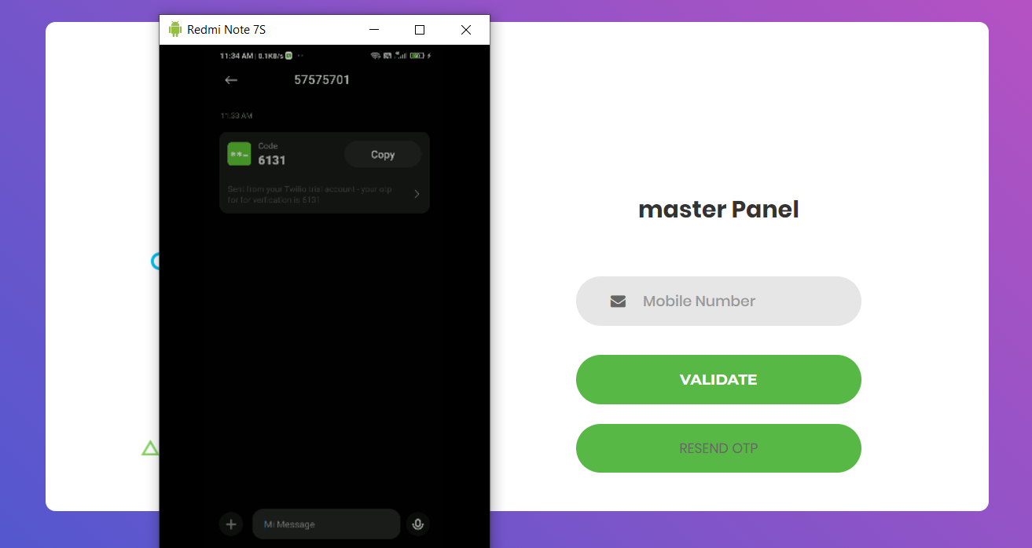

**V. update Aadhar**

1. **verification**

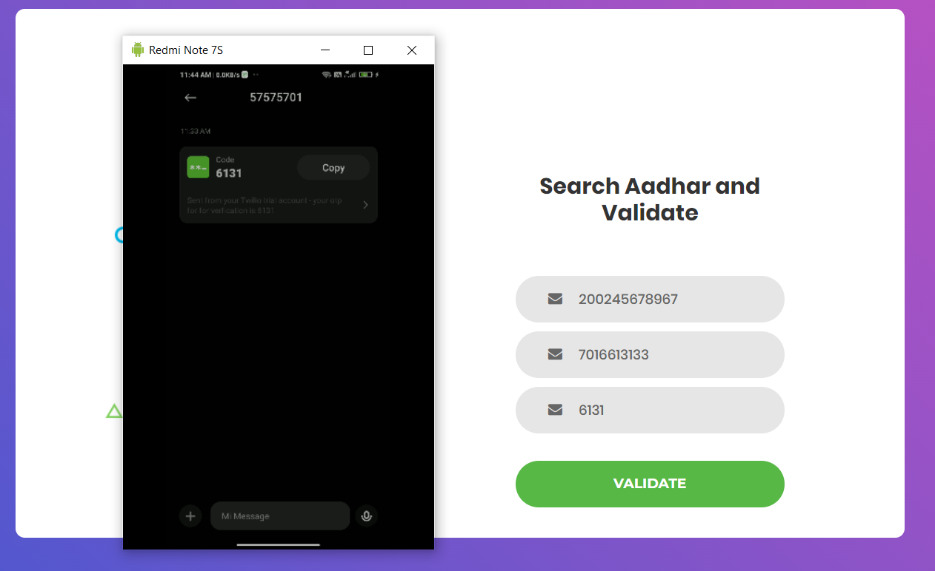

1. **update panel**

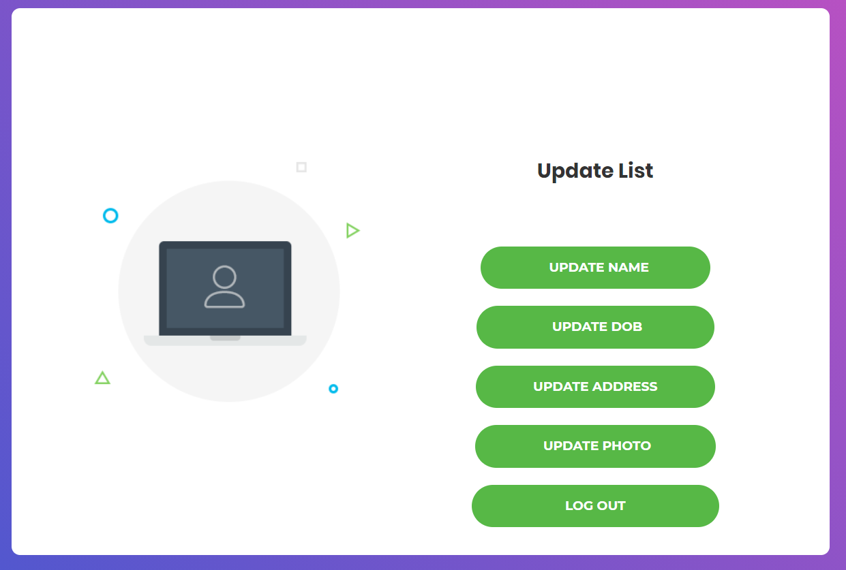

**VI. download/view Aadhar**

1. **verification**

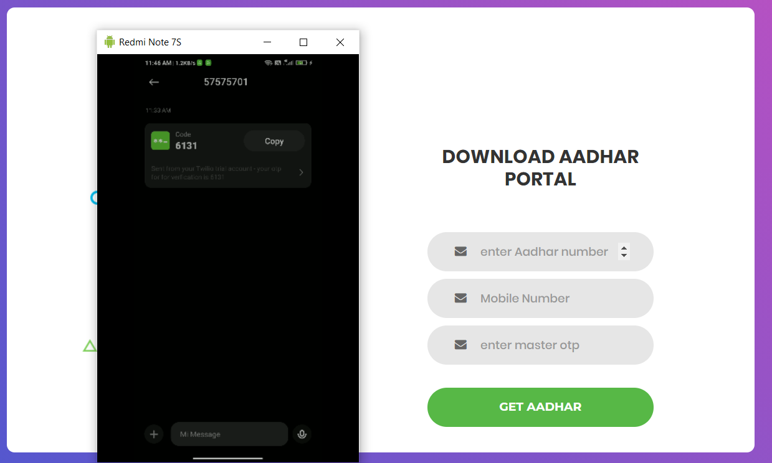

1. **view Aadhar**

**front:**

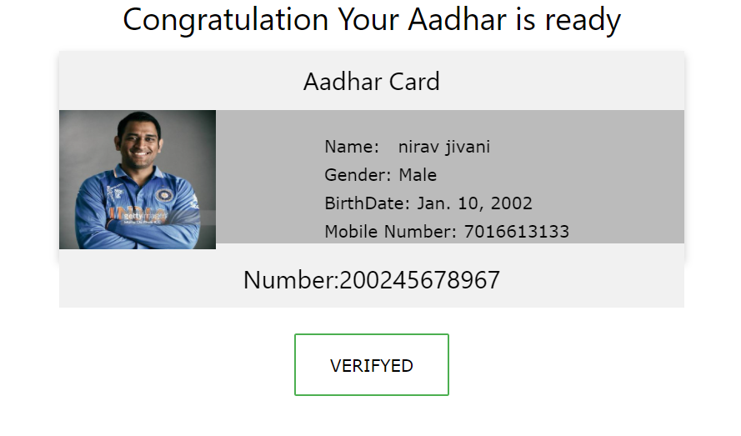

**Move arrow to card and flip**

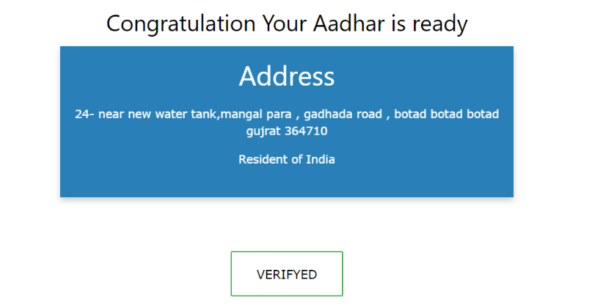

**Logout:**

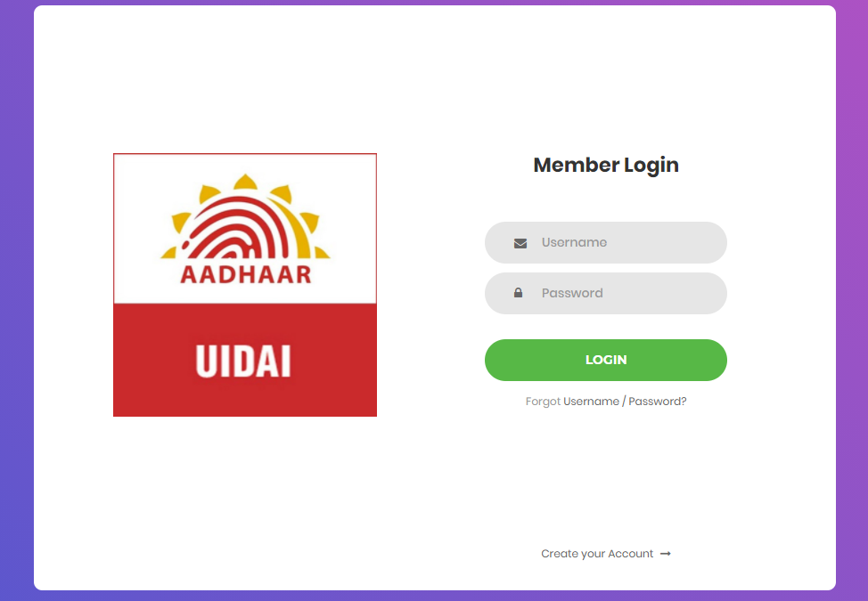

**8. Conclusion**

By implementing online Aadhar card application web, we can archive a goal of digital India and new Aadhar get very rapidly instead of offline application. It also help user to update their details at home or any place and any time. This web also helpful in this covid-19 situation to avoid crowd at gov corporation. User can also download digital copy of their Aadhar card. It can use print Aadhar card if user have to submit Aadhar card copy and he/she forgot their physical Aadhar at home. This all point of view, this web app is very useful.

**9. Limitation and future extension**

Limitation:

This is very basic application. Less security for gov database and some background process done by gov employee is ignored. like user document verification, physical Aadhar card does not sent to user address.

Future Extension:

User interface will be improved to provide better interaction with system. Background processes and Thread execution will be efficient and process load will be reduced. We also add some more functionality like Aadhar linking status with bank , Aadhar and voter id linking and more..

**10. Bibliography**

Websites :

<https://docs.djangoproject.com/en/3.1/>

<https://www.w3schools.com/>

https://stackoverflow.com/

Search Engine: [www.google.com](http://www.google.com/)